Exercise 2: Verifying Interactions Using Mockito

**📁 Project Structure**

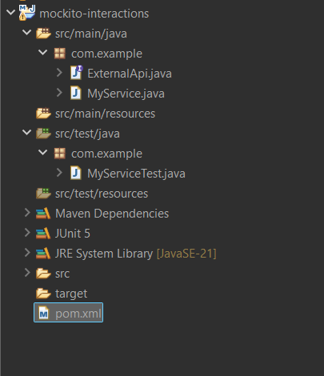

**📄 ExternalApi.java**

package com.example;

public interface ExternalApi {

void getData();

}

**🧩 MyService.java**

package com.example;

public class MyService {

private final ExternalApi api;

public MyService(ExternalApi api) {

this.api = api;

}

public void fetchData() {

api.getData();

}

}

**🧪 MyServiceTest.java**

package com.example;

import static org.mockito.Mockito.*;

import org.junit.jupiter.api.Test;

public class MyServiceTest {

@Test

public void testVerifyInteraction() {

// Step 1: Create a mock

ExternalApi mockApi = mock(ExternalApi.class);

// Step 2: Inject the mock into the service

MyService service = new MyService(mockApi);

// Step 3: Invoke the method under test

service.fetchData();

// Step 4: Verify interaction with the mock

verify(mockApi).getData();

}

}

**⚙️ pom.xml (Maven Configuration with Java 21 support)**

<project xmlns="http://maven.apache.org/POM/4.0.0"

xmlns:xsi="http://www.w3.org/2001/XMLSchema-instance"

xsi:schemaLocation="http://maven.apache.org/POM/4.0.0

https://maven.apache.org/xsd/maven-4.0.0.xsd">

<modelVersion>4.0.0</modelVersion>

<groupId>com.example</groupId>

<artifactId>mockito-interaction-test</artifactId>

<version>1.0-SNAPSHOT</version>

<properties>

<maven.compiler.source>21</maven.compiler.source>

<maven.compiler.target>21</maven.compiler.target>

</properties>

<dependencies>

<!-- JUnit 5 -->

<dependency>

<groupId>org.junit.jupiter</groupId>

<artifactId>junit-jupiter</artifactId>

<version>5.10.0</version>

<scope>test</scope>

</dependency>

<!-- Mockito -->

<dependency>

<groupId>org.mockito</groupId>

<artifactId>mockito-core</artifactId>

<version>5.12.0</version>

<scope>test</scope>

</dependency>

</dependencies>

<build>

<plugins>

<!-- Run tests using Surefire -->

<plugin>

<groupId>org.apache.maven.plugins</groupId>

<artifactId>maven-surefire-plugin</artifactId>

<version>3.2.5</version>

</plugin>

</plugins>

</build>

</project>

Output :

